DFIR Phishing Incident Response (Enterprise Email Forensics Case)

Objective
Analyze an enterprise workstation compromise by performing forensic triage on malicious email headers, decoding obfuscated execution artifacts, and correlating host and network logs to establish a chronological intrusion timeline.

Scenario
A finance employee at a logistics firm received a highly targeted follow-up email regarding an unpaid invoice from a known packaging business partner. Unbeknownst to the employee, this was a sophisticated phishing attack containing a weaponized attachment that compromised the host or workstation upon execution.
As the responding SOC Analyst, I flagged the anomalous execution of the attachment, correlating it with corresponding phishing reports submitted by other personnel within the finance division. Threat intelligence and TTP mapping indicate that the initial delivery mechanisms align directly with an emerging threat group actively targeting the logistics sector.

Skills Learned
- Email Header & Forensic Analysis
- Log Triage & Structured Parsing
Tools Used
- Thunderbird (free and open-source cross-platform email client)
- mha.azurewebsites.net (Online email analyzer)
- lnkparse (LNK parsing tool in CLI)
- Cyberchef.com (intuitive web-based application)

Artifacts
- dump.eml (Copy from the phishing email)
- powershell.json (Powershell Logs from the finance employee’s host or workstation)
- capture.pcapng (Packet capture from the same workstation)

Phases:
Phase 1: (Phishing) Email Analysis/Forensics
To understand how this .eml artifact was acquired, I flagged the anomalous endpoint execution on the employee’s workstation, and respond by using an automated containment playbooks to run an enterprise-wide search. I would locate the specific message ID within the employee’s mailbox and export the message directly as a standard .eml forensic artifact to investigate the initial access vector. In this case, I will be using Thunderbird to open the EML file from the phishing email.
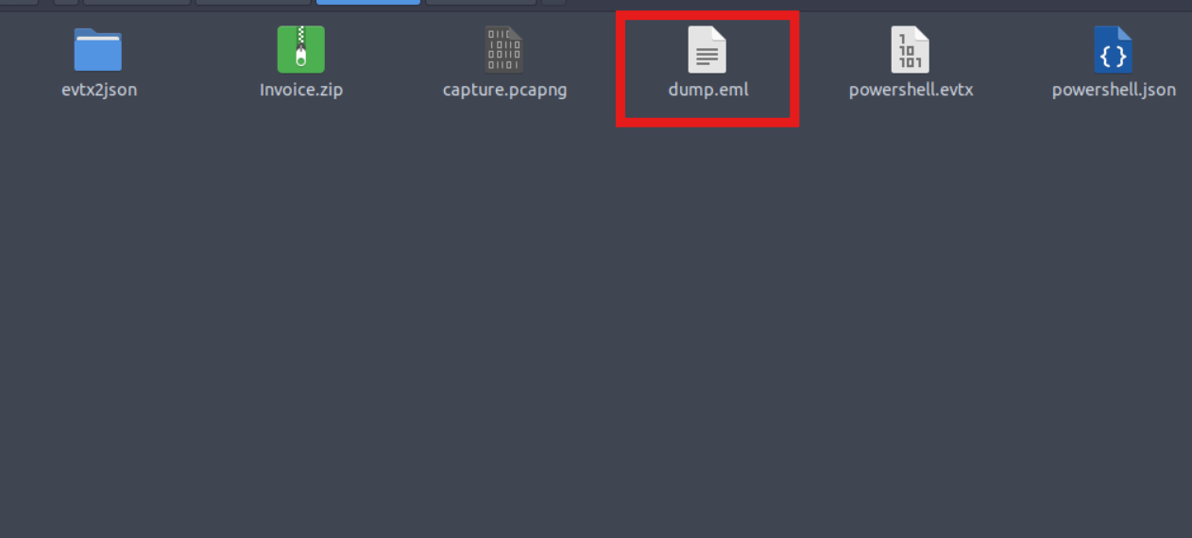

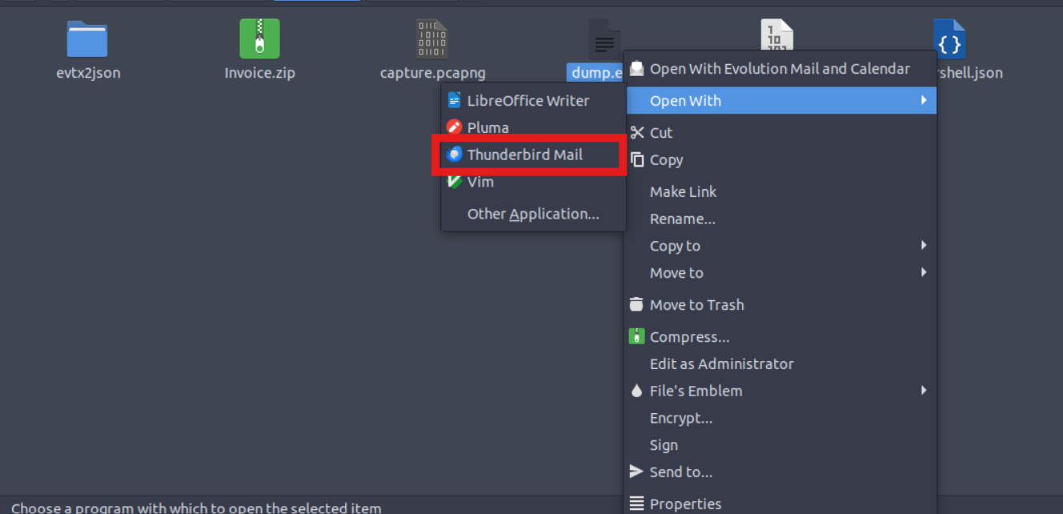
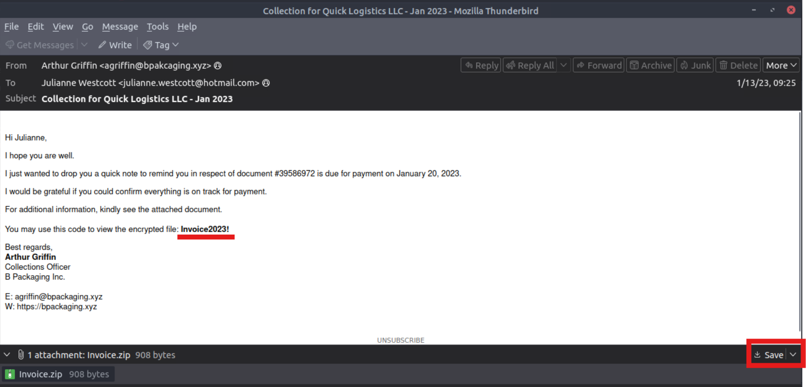
Based on the email content, I took note of the email address used to send the phishing email and that is agriffin@bpakcaging.xyz. Aside from that, I noticed that there’s also a typosquatting. Instead of using the word, “packaging”, the attacker used a misspelled word, and that is “pakcaging”, which looks odd or strange.

After that, I downloaded the Invoice.zip and extract using the terminal or command-line interface (CLI), at the same time, input the password, which is the Invoice2023!, that has been provided inside the email content. The file inside the zip files was, Invoice_20230103.lnk.
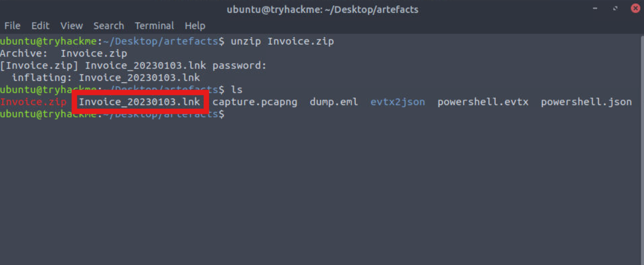

I will be using a lnkparse tool against Invoice_20230103.lnk file, in order for me to find the encoded payload Command-line arguments.
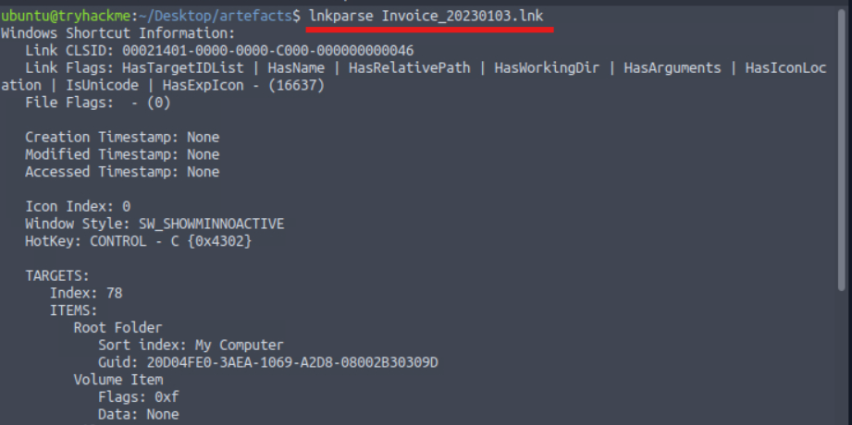
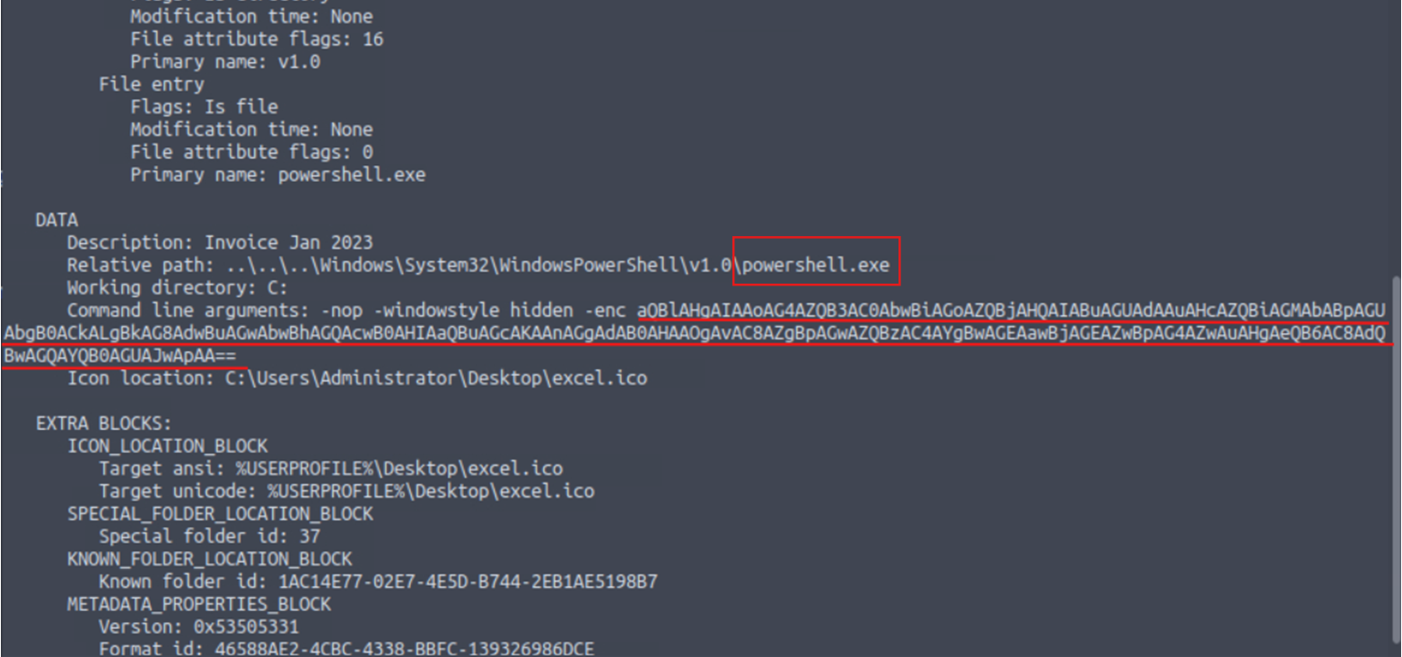

To decode this Command-line arguments, I will be using Cyberchef tool. I tried different operations and ended up by using from base64.
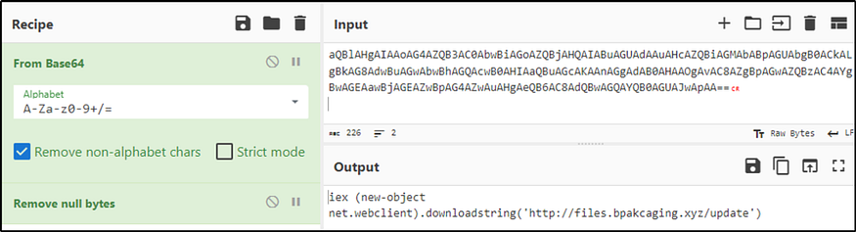
As you can see, the output result is an example of a C2 "cradle" or downloader. While the DownloadString method itself is a legitimate administrative tool created by Microsoft, the specific way it is packaged in the string—hidden inside a Base64-encoded PowerShell command—is a classic indicator of malicious C2 activity.

In order for me to find the name of the third-party mail relay serviced used by the attacker based on the DKIM-Signature and List-Unsubscribe headers, I checked the View Source of the said email.
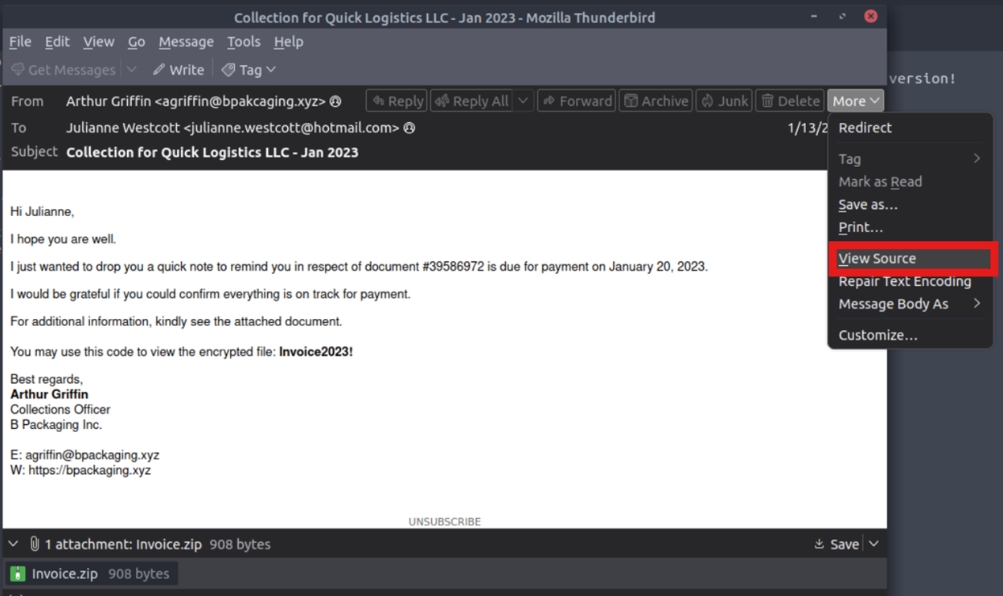
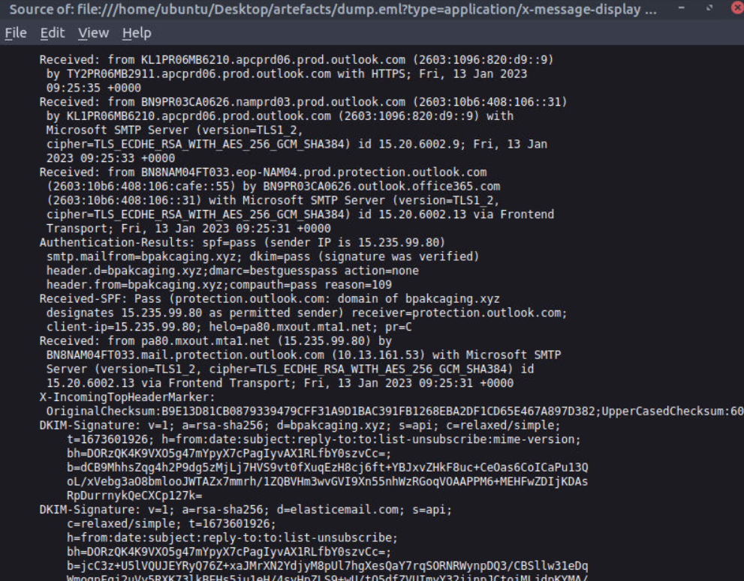

In order to make this easy to find the third-party mail, I used the tool, mha.azurewebsites.net. I found out also that the third-party mail relay service used was elasticmail.
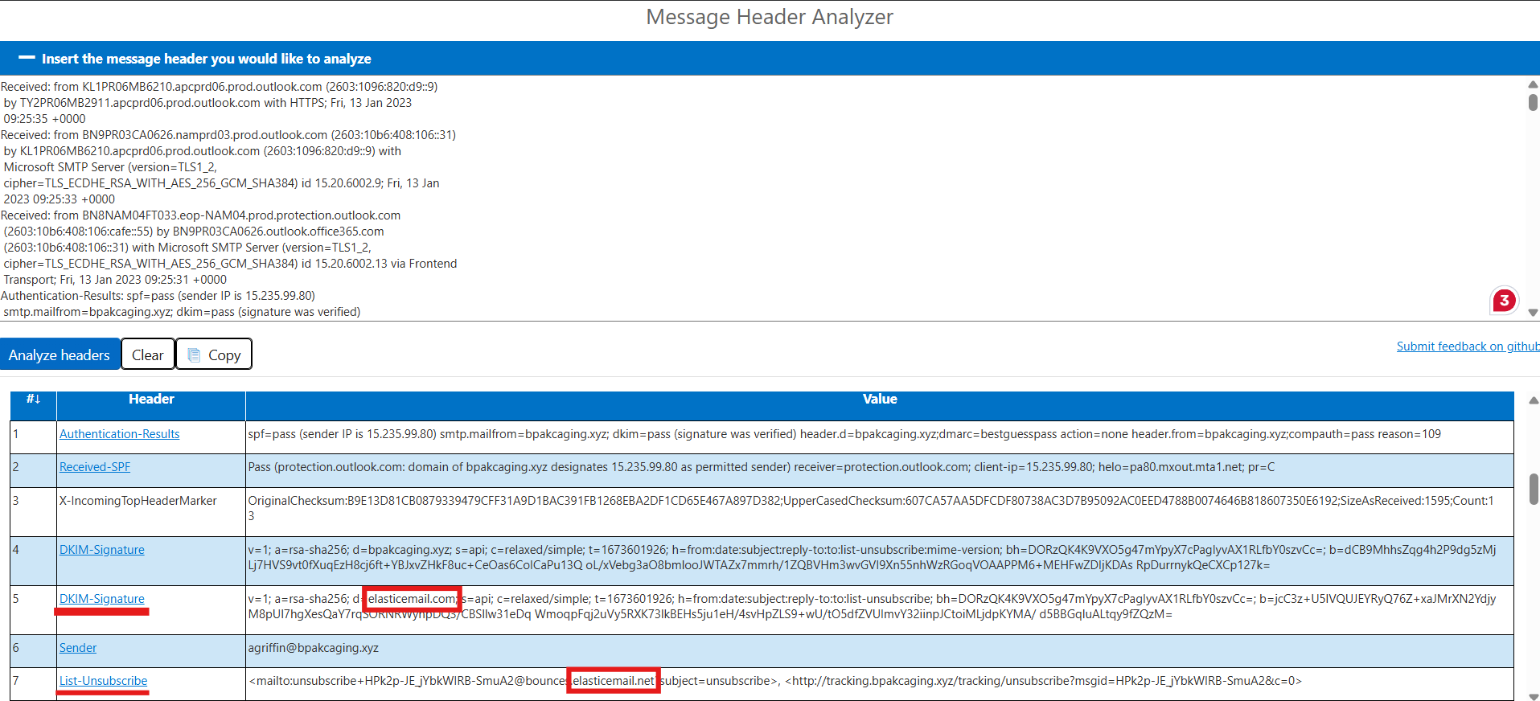

Phase 2: Host Execution & Artifact Forensic Analysis
Now, on the initial findings, I discovered how the malicious attachment compromised the employee’s workstation; through the execution of PowerShell command, as well as, decoding the payload, which reveals the starting point of endpoint activities.
With these discoveries,I should now proceed with analyzing the PowerShell logs (Powershell.json) to uncover the potential impact of the attack. I can start to analyze by searching the execution of the initial payload in the PowerShell logs.
Since the given artifact or data is JSON, I have to know the manual or documentation on how can I execute a command for JSON in CLI. I reasearched online and found this. I used jq and different commands.

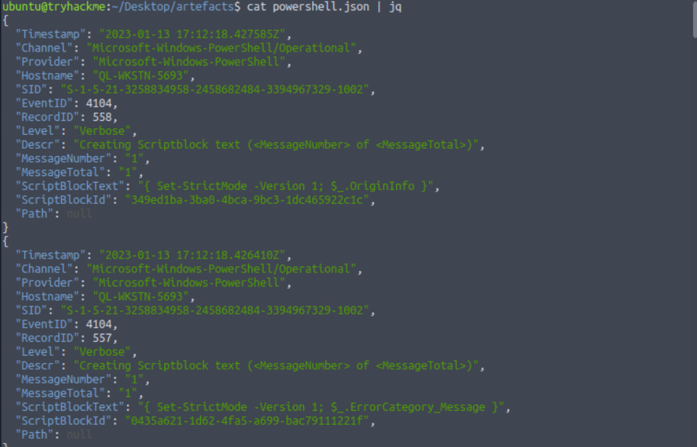

I am using a command that will filter only the fields in the file which I can find helpful in the task.
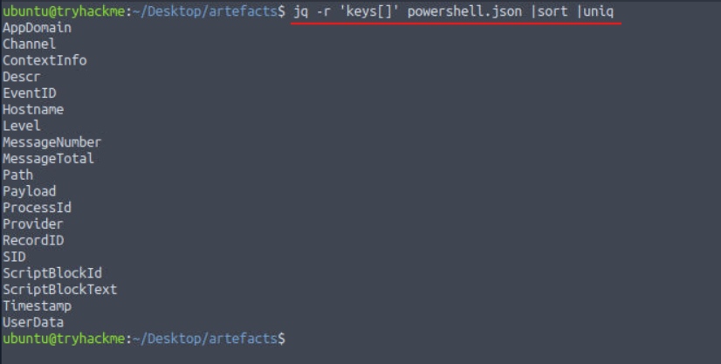

I am going to sort the logs based on their Timestamp and print multiple field values by using ScriptBlockText as the field text.
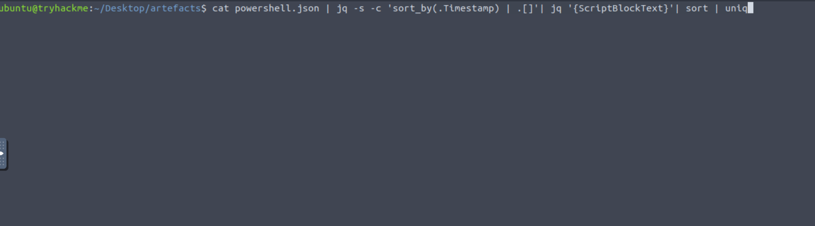

Based on my investigation, the domains used by the attacker for file hosting and command-and-control (C2) are; cdn.bpakcaging.xyz and files.bpakcaging.xyz. Aside from that, I found out that the name of the enumeration tool downloaded by the attacker is Seatbelt.
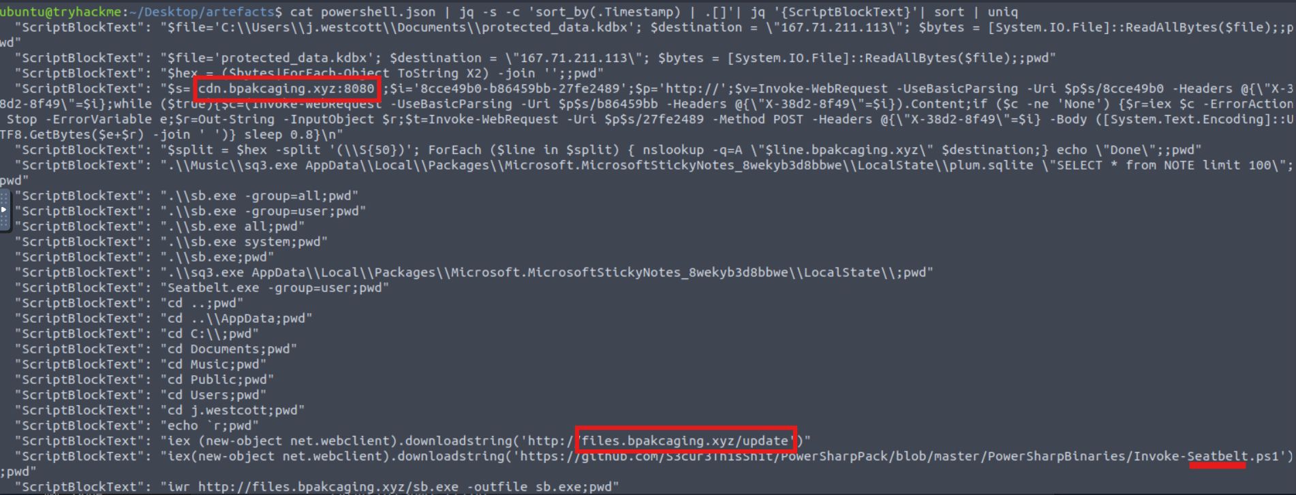

Using the same result, the file accessed by the attacker using the downloaded sq3.exe, a legitimate command-line tool used to view and manage database files, binary is C:\\Users\\j.westcott\\AppData\\Local\\Packages\\Microsoft.MicrosoftStickyNotes_8wekyb3d8bbwe\\LocalState\\plum.sqlite. I used the same command but grep the important details, so that it would help me to locate it easily. Another thing is that, Microsoft Sticky Notes is the software that uses the file.
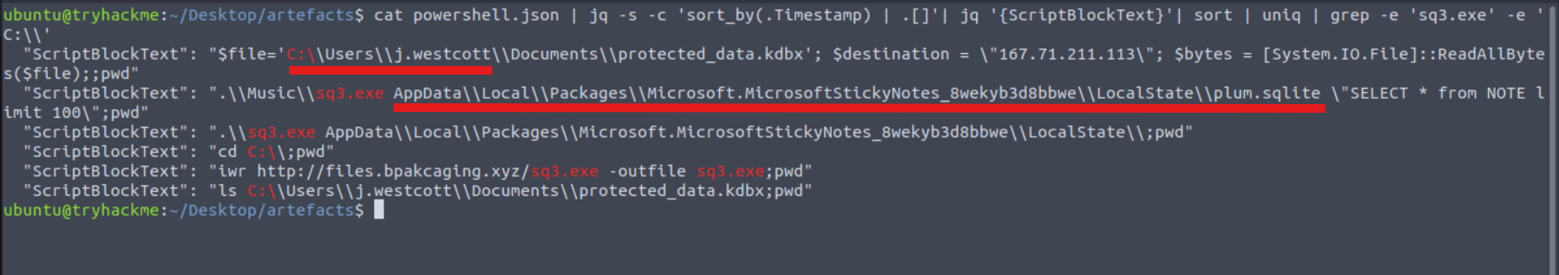

The name of the exfiltrated file by the attacker was protected_data.kdbx.
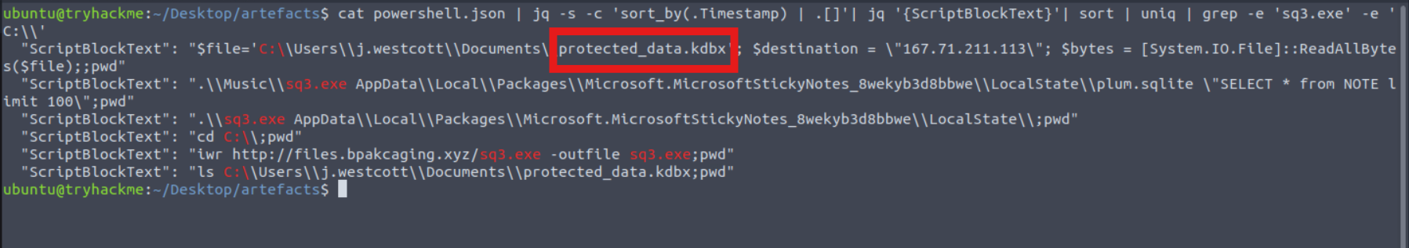

Based from that result, I was wondering what type of file uses the .kdbx file extension, thus, I tried to search online (Google.com), since I cannot find the answer based from the result. To answer this question, I found out that it is the KeePass 2.
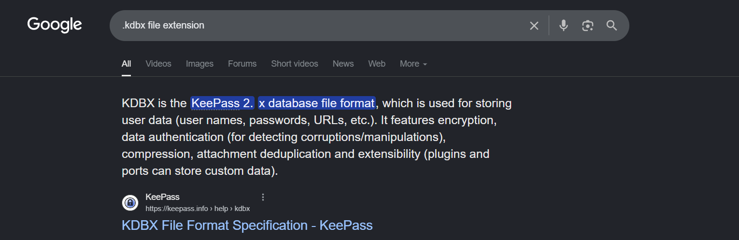

The encoding used during the exfiltration attempt of the sensitive file was hex and the tool used for exfiltration was nslookup.
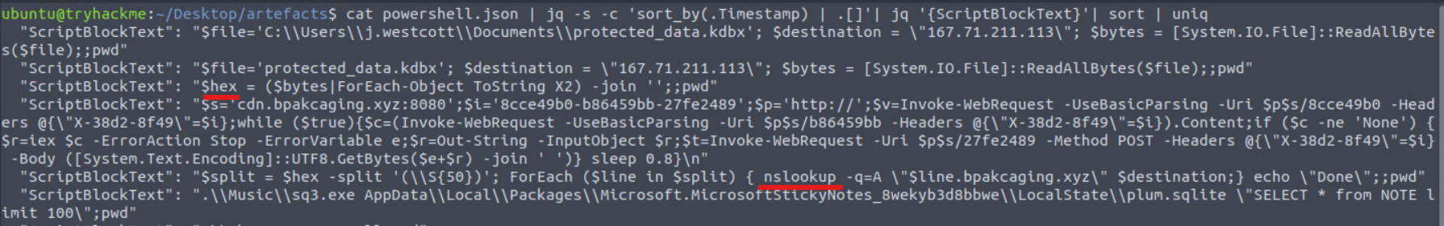

Phase 3: Network Traffic Analysis & Exfiltration Identification/Triage
Based on the PowerShell logs investigation, I now have seen the full impact of the attack; such as the threat actor was able to read and exfiltrate two potentially sensitive files (protected_files.kdbx & plum.sqlite), and the domains and ports used for network activity were discovered (cdn.bpakcaging.xyz:8080 and files.pakcaging.xyz), which includes also the tool used by the threat actor for exfiltration.
I utilized the packet capture (capture.pcapng) and opened it with Wireshark. By searching for sq3.exe, I investigated on what software is used by the attacker to host its presumed file/payload server through the input of files.bpakcaging.xyz on the search bar and found out that the attacker was using Python.
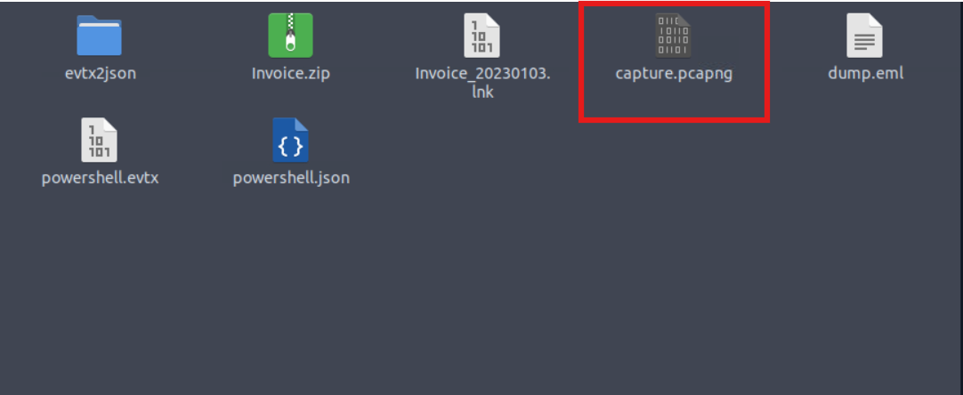

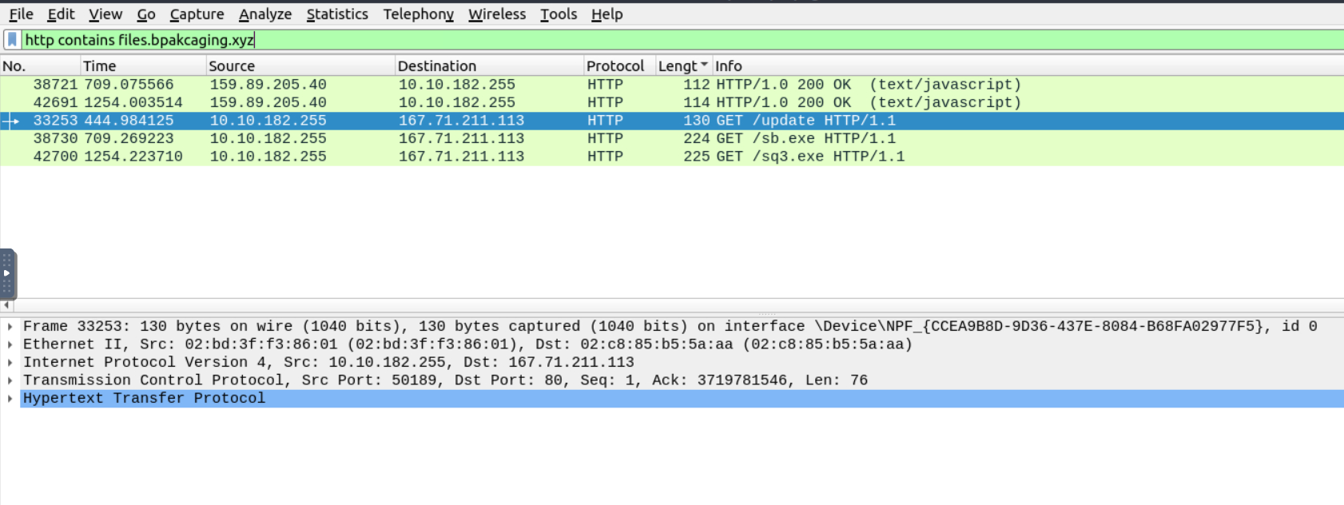

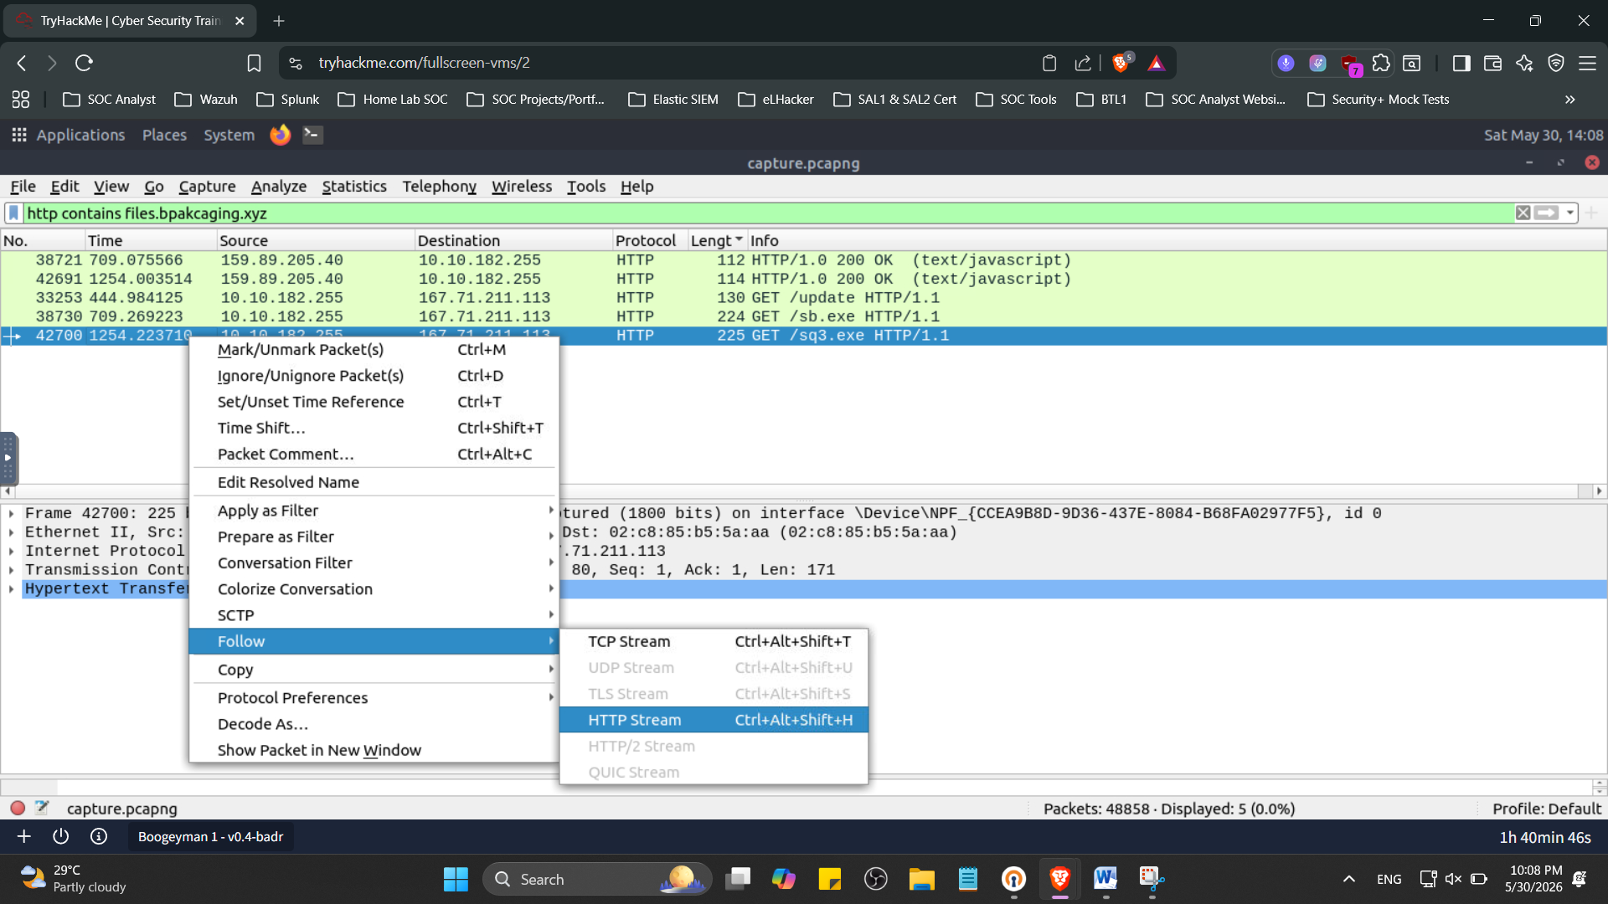
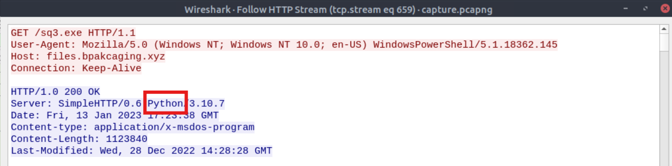

Based from the previous result from Phase 2, the HTTP method is used by the C2 for the output of the commands executed by the attacker was POST method.
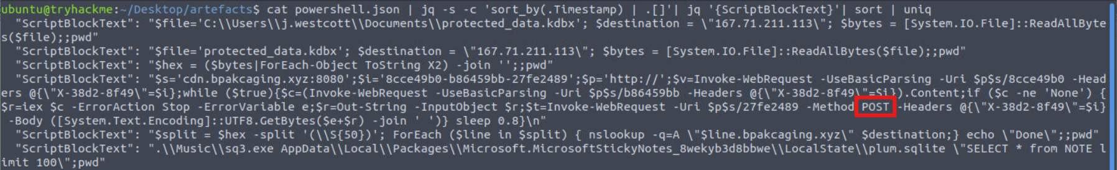

In order to know what was the password of the exfiltrated file, I have to investigate again in Wireshark through the input of sq3.exe.

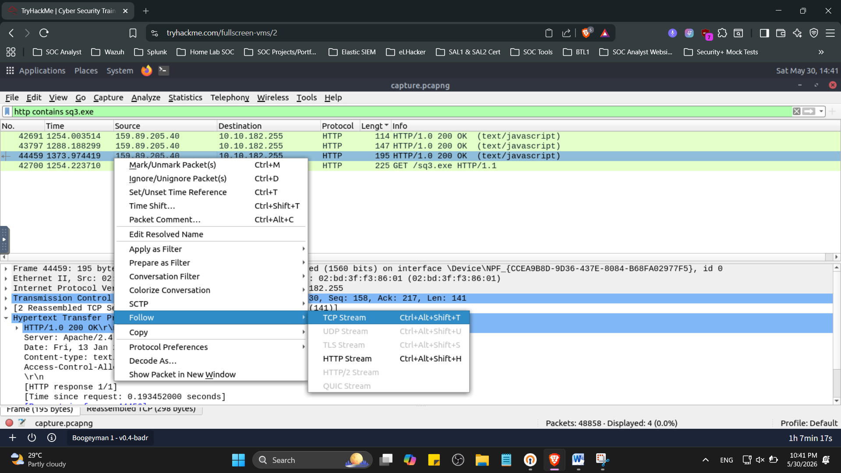
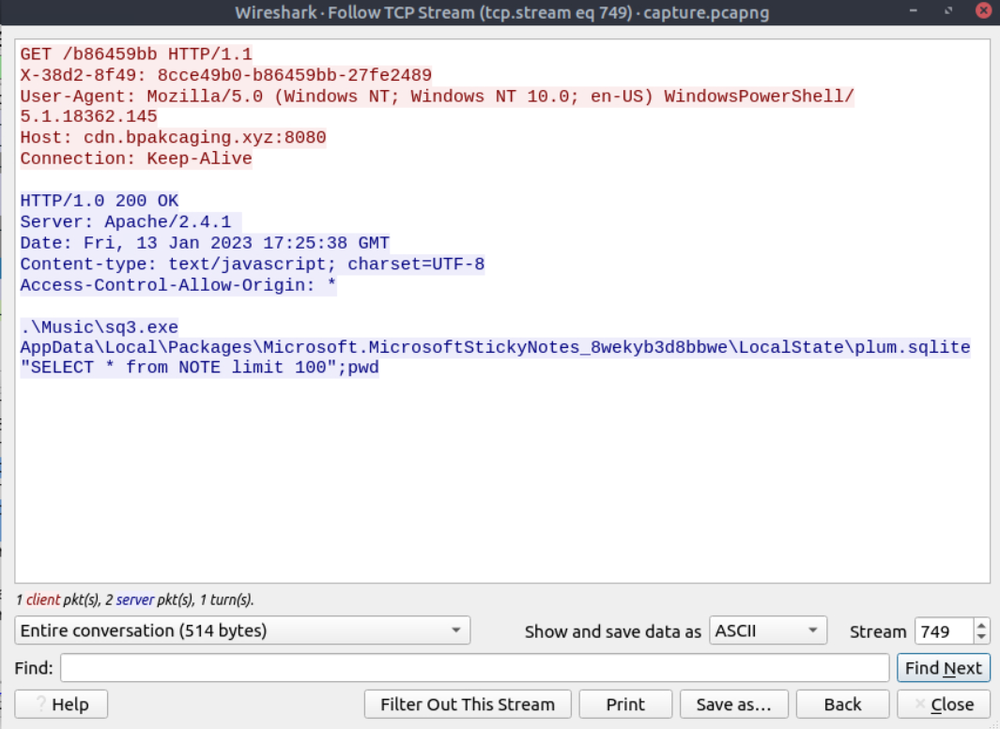

I will be changing the Stream into 750 and see what happens to the data exfiltrated. As what I observed, it shows up a lot of numbers, thus, I copied the numbers or characters and pasted them in Cyberchef to be decoded.
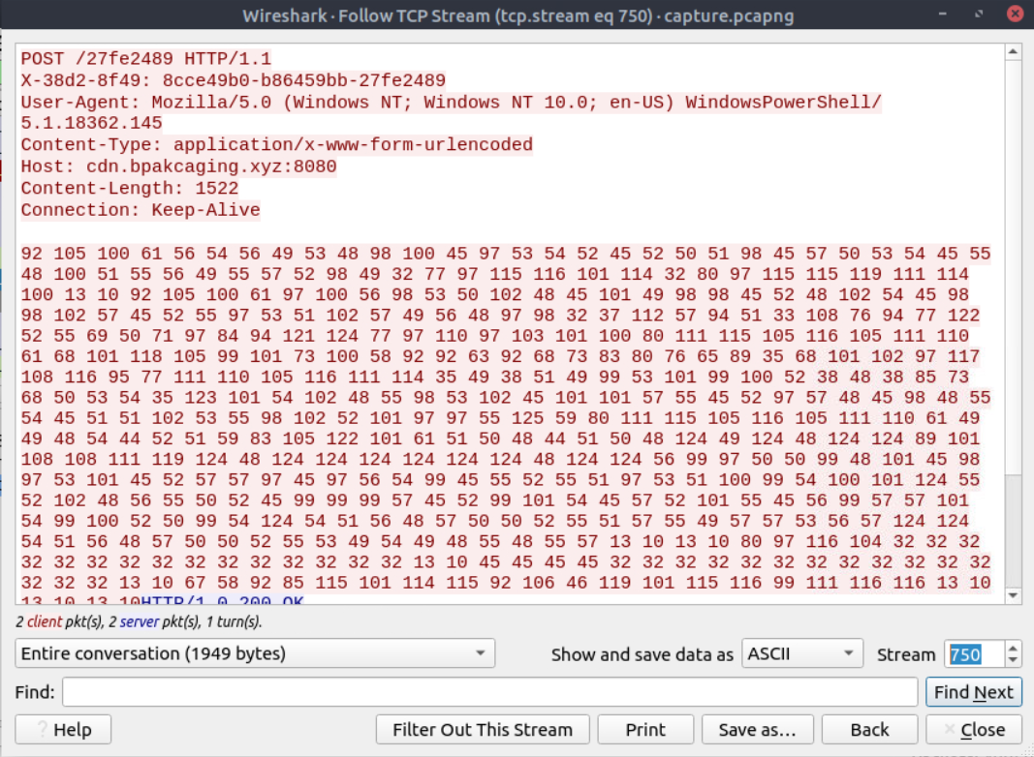

I used “Magic” to initially identify what type of characters they were.
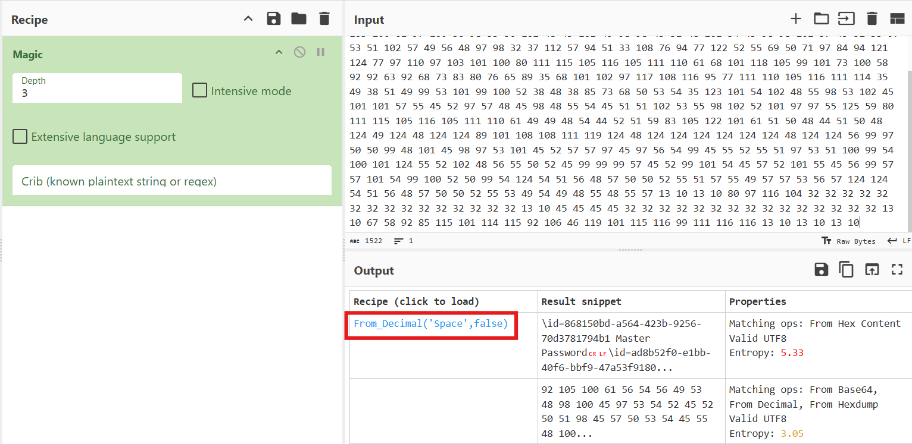
By clicking or selecting “From_Decimal” as the recipe, the master password for the exfiltrated file is now retrieved.
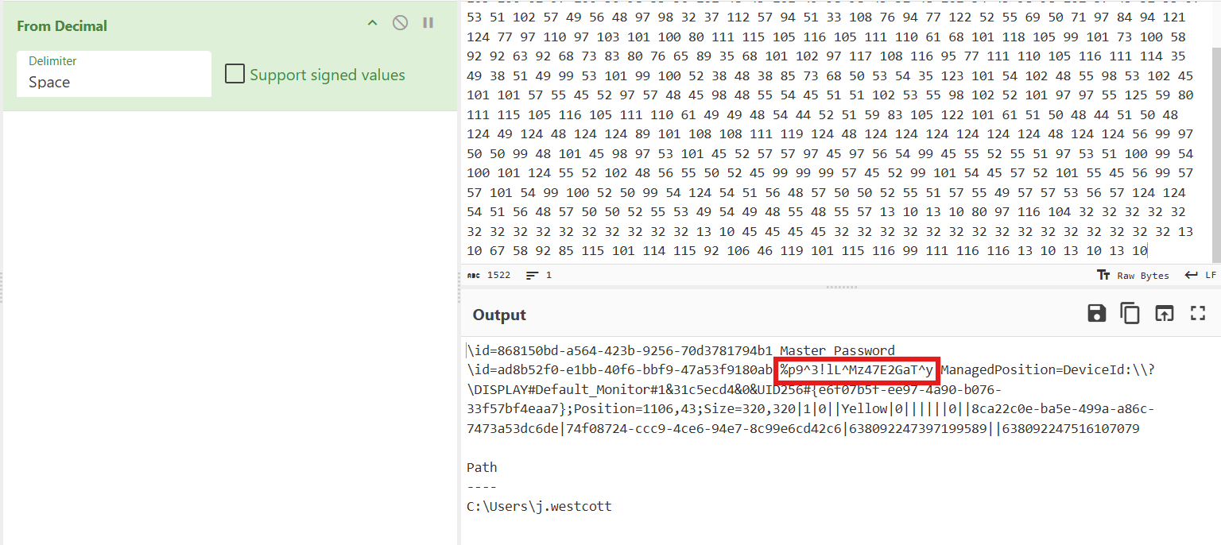

Another important and sensitive information is the credit card number, which was stored inside the exfiltrated file. By using Wireshark, I built a display filter that utilizes the info I got from the previous Phase, (dns) nslookup -q=A. I took note also with the IP address, which is the 167.71.211.113. In the Wireshark GUI, select the “Analyze” and select “Display Filter Expressions”.
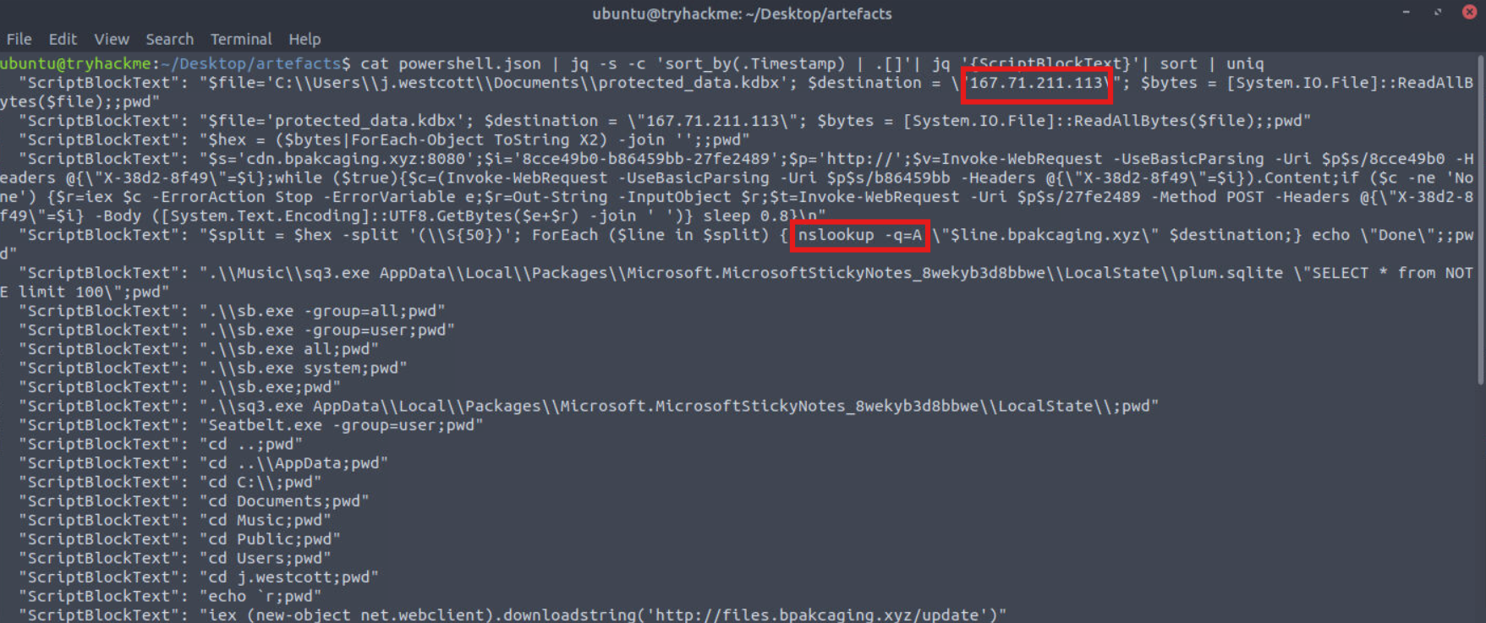

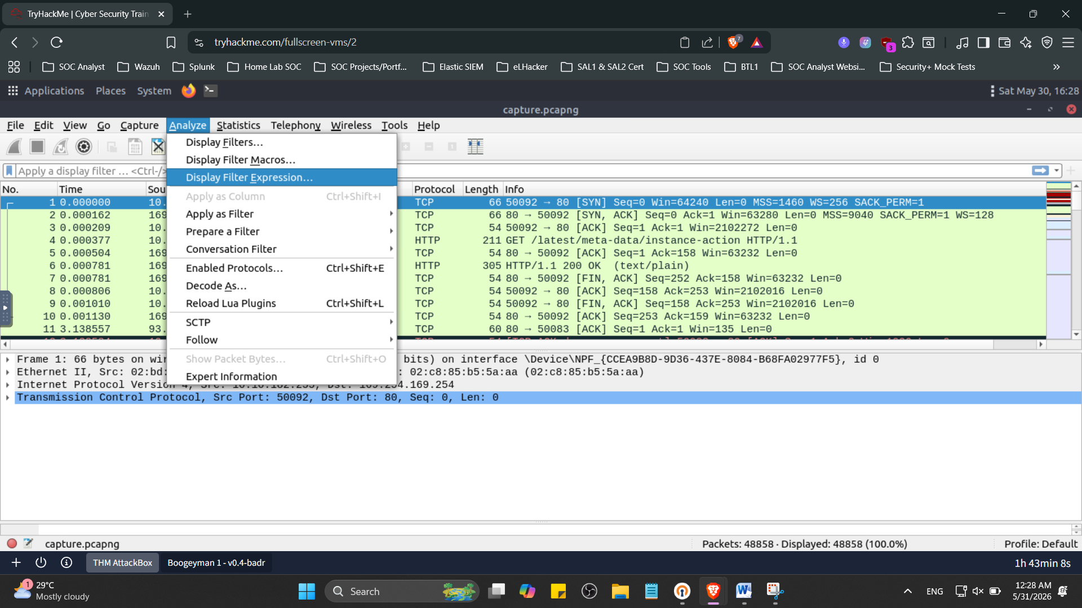
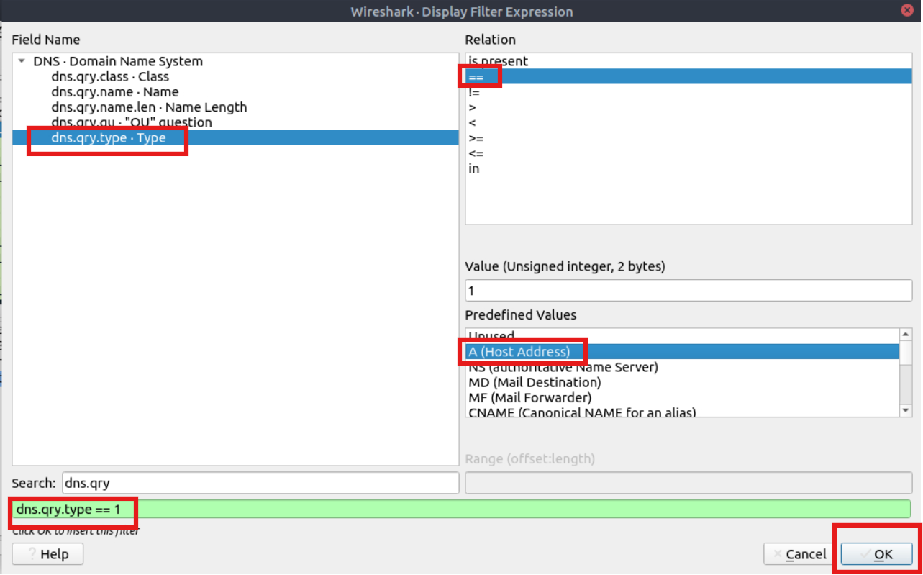

Here, I add the IP address in the search bar that I took note, just in case it will give me more information. However, the result provides me a lot of details or information.
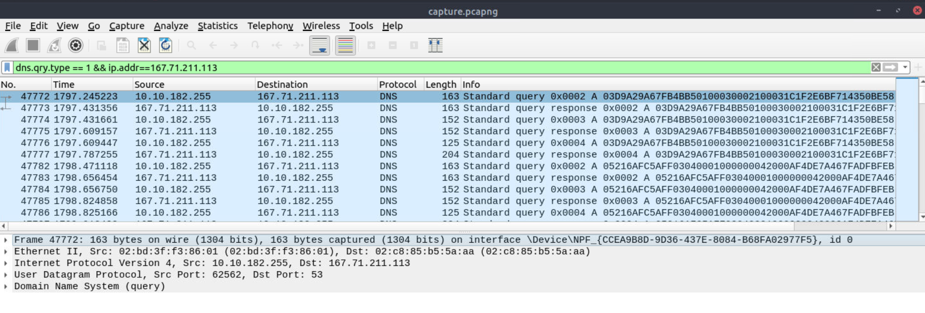

I will be using TShark to analyze the captured DNS traffic and extract only the encoded data being exfiltrated. Based from my previous learnings in TShark, I will be using a command that will read from the pcap file provided, apply “dns” as a display filter, and display packets that only include the DNS query name field. It will then grep lines that contain a keyword associated with the destination domain.
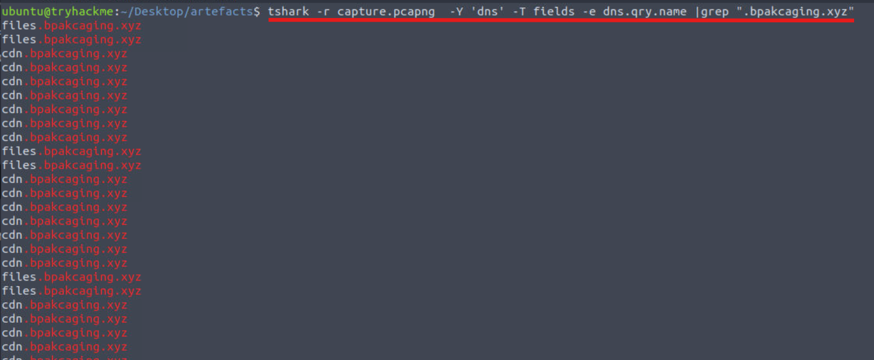

The concern from the result is duplicates and unnecessary strings or characters, thus, I have to modify the command that will split each line by the delimeter “.” and select only the first field or column. It will then perform an inverse match for “files” and “cdn”, which means that those will not be included in the result or remove any duplicates.
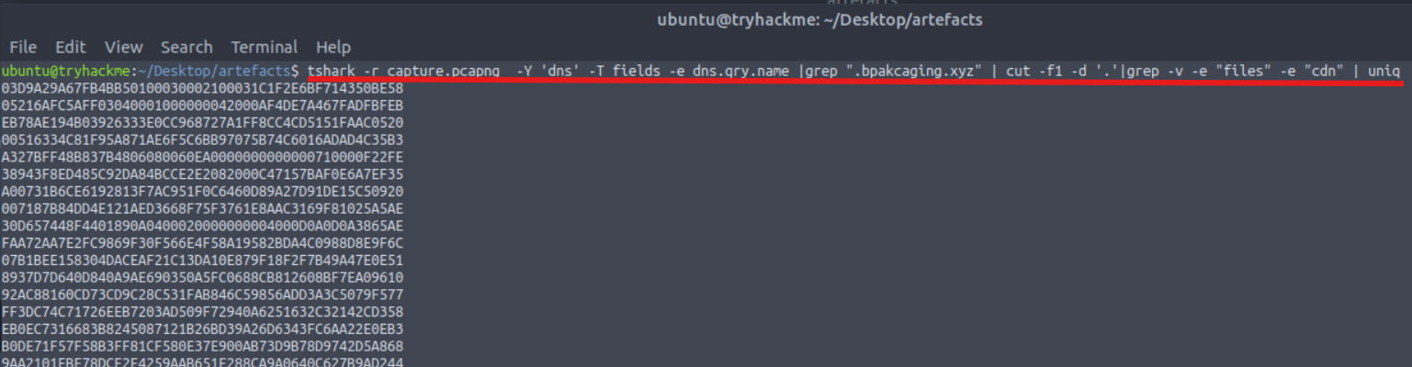

Now, I need to remove the empty spaces or newlines, thus, I used “tr” in order to make the output in one line of text.

MITRE ATT&CK

Lesson Learned

